Panasas Scale-Out NAS Solution For Manufacturing

A Broadband-Testing Report
By Steve Broadhead, Founder & Director, BB-T

First published July 2017 (V1.0)

Published by Broadband-Testing
A division of Connexio-Informatica 2007, Andorra

Tel : +376 633010
E-mail : info@broadband-testing.co.uk
Internet : HTTP://www.broadband-testing.co.uk

@2017 Broadband-Testing

All rights reserved. No part of this publication may be reproduced, photocopied, stored on a retrieval system, or transmitted without the express written consent of the authors.

Please note that access to or use of this Report is conditioned on the following:

- The information in this Report is subject to change by Broadband-Testing without notice.

- The information in this Report, at publication date, is believed by Broadband-Testing to be accurate and reliable, but is not guaranteed. All use of and reliance on this Report are at your sole risk. Broadband-Testing is not liable or responsible for any damages, losses or expenses arising from any error or omission in this Report.

- NO WARRANTIES, EXPRESS OR IMPLIED ARE GIVEN BY Broadband-Testing. ALL IMPLIED WARRANTIES, INCLUDING IMPLIED WARRANTIES OF MERCHANTABILITY, FITNESS FOR A PARTICULAR PURPOSE AND NON-INFRINGEMENT ARE DISCLAIMED AND EXCLUDED BY Broadband-Testing. IN NO EVENT SHALL Broadband-Testing BE LIABLE FOR ANY CONSEQUENTIAL, INCIDENTAL OR INDIRECT DAMAGES, OR FOR ANY LOSS OF PROFIT, REVENUE, DATA, COMPUTER PROGRAMS, OR OTHER ASSETS, EVEN IF ADVISED OF THE POSSIBILITY THEREOF.

- This Report does not constitute an endorsement, recommendation or guarantee of any of the products (hardware or software) tested or the hardware and software used in testing the products. The testing does not guarantee that there are no errors or defects in the products, or that the products will meet your expectations, requirements, needs or specifications, or that they will operate without interruption.

- This Report does not imply any endorsement, sponsorship, affiliation or verification by or with any companies mentioned in this report.

- All trademarks, service marks, and trade names used in this Report are the trademarks, service marks, and trade names of their respective owners, and no endorsement of, sponsorship of, affiliation with, or involvement in, any of the testing, this Report or Broadband-Testing is implied, nor should it be inferred.

TABLE OF CONTENTS
i
TABLE OF CONTENTS 1
Broadband-Testing 2
Executive summary 3
Scale-out NAs is not all created equal… 3
Overview: The Panasas Take On Next Generation Storage 4
The Panasas Solution For manufacturing 5
Manufacturing – The Compute Challenge 5
The Panasas Solution: An Overview 7
Deployment And Management 8
In Conclusion 10

Figure 1 – The Panasas Approach To Data Access 4
Figure 2 – ActiveStor 20 Shelf 7
Figure 3 – Per-File RAID System 9
Figure 4 – PanActive Management GUI 10

Broadband-Testing

Broadband-Testing is Europe’s foremost independent network testing facility and consultancy organisation for broadband and network infrastructure products.

Based in Europe, Broadband-Testing provides extensive test demo facilities. From this base, Broadband-Testing provides a range of specialist IT, networking and development services to vendors and end-user organisations throughout Europe, SEAP and the United States.

Broadband-Testing is an associate of the following:

Limbo Creatives (bespoke software development)

Broadband-Testing Laboratories are available to vendors and end-users for fully independent testing of networking, communications and security hardware and software.

Broadband-Testing Laboratories operates an Approvals scheme which enables products to be short-listed for purchase by end-users, based on their successful approval.

Output from the labs, including detailed research reports, articles and white papers on the latest network-related technologies, are made available free of charge on our web site at HTTP://www.broadband-testing.co.uk

Broadband-Testing Consultancy Services offers a range of network consultancy services including network design, strategy planning, Internet connectivity and product development assistance.

Executive summary
- Network Attached Storage (NAS) from the 2000s was designed for data and applications of its time, but time has moved on.
- Scalability requirements are way beyond what they were even just a few years ago. Data on demand requirements mean scalable storage on demand, with all but zero deployment time and latency-free performance.
- Panasas has created a scale-out NAS solution designed to work in the most demanding contemporary environments, notably manufacturing, research, energy and media and entertainment.
- In these industries compute demands are incredibly high, as is reliability. Legacy NAS is unable to keep up with the input/output (I/O) requirements of the highly data-intensive calculations required, such as in Computational Fluid Dynamics (CFD).
- With the Panasas solution, both initial deployment and scale-out are near instantaneous. This is supported equally by data access performance and consistent availability.
- IT is not about “one size fits all”, it is about “fit for purpose”; Panasas’s approach is completely in line with this concept and has genuinely been designed to “fit” verticals such as manufacturing and the set of requirements demanded.

Scale-out NAs is not all created equal…
While Network Attached Storage (NAS) is still considered as a relatively new option for some companies, it has actually been around since the 90s, and popularised in the early-mid 2000s.
Herein lays one fundamental – and classic IT – problem; NAS solutions designed 15 years ago were designed to solve 15 year-old problems. IT has moved on in every area since, but especially so in the realms of data, storage and their related applications. Data usage has both increased massively and changed in terms of its form, function and access requirements. Part of this is due to the dramatic reduction in the cost of storage per megabyte (or should we say petabyte) of data and in the sheer volume of data we can now store in a tiny form factor, hence reducing power requirements, as well as lowering CapEx costs. However, the applications themselves have also changed, especially in their requirement to access data as quickly, efficiently and reliably as possible.
In the mid 2000s, we at Broadband-Testing were looking at the new NAS kids on the block (Server Message or otherwise!) back then, and it was all about simplifying file access, migration and backup – in other words, a virtual single file system. And at that time, this was a significant breakthrough, as with it came improved speed of deployment and a reduction in the amount of human day-to-day management required. Those latter two elements are still relevant in today’s world of scale-out NAS deployments, except the ante is well and truly upped, due to the amount of data traffic coming on line by the day, hour, minute and second. Gone are the days when a company could spend months capacity planning for the next 5-10 years. Now it’s more like 5-10 minutes.
Consequently, the first or even second generation NAS architectures are out of kilter –islands of storage developed as a direct consequence of scaling traditional NAS technology and this approach simply doesn’t work any longer. Hence, the overused “scale-out” buzz phrase that every NAS provider on the planet is using – no vendor can afford to admit they cannot cope with the required pace of storage expansion for most companies in most industries. However, when it comes to certain verticals, such as manufacturing – our focus in this paper – that scale-out requirement, and its related benefits of performance and ease and speed of deployment, become hyper-critical. After all, a 24x7 manufacturing plant can’t shut down “over the weekend” for planned upgrades. Well, it can, but it won’t be in business by the Monday…

Overview: The Panasas Take On Next Generation Storage
What is required, then, in the world of manufacturing, as well as several other verticals, such as scientific research, energy and media and entertainment, are some very specific capabilities that allow the storage solution to keep apace with the company and its business.
This does not mean adapting 15+ year old technology; that simply doesn’t work. Here, then, we look at what one vendor whose focus is on contemporary scale-out NAS, Panasas, has created in order to achieve what it believes to be a solution capable of supporting the needs of modern manufacturing, with a parallel, scalable approach to file access.
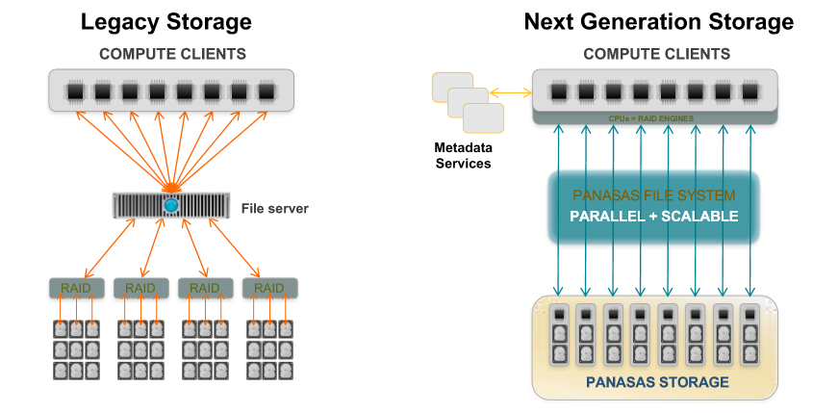
Figure 1 – The Panasas Approach To Data Access
If we take a quick look at legacy storage architecture, the limitations are glaringly obvious from a performance perspective. Using a file server in the data path means it is responsible for managing all requests. This creates a classic bottleneck and the inevitable congestion that ensues, limiting scalability. Hence, we have the “islands of data” scenario, itself a potential management nightmare, not least from a capacity planning perspective.
The Panasas answer to this conundrum is to use parallel access to data, with clients accessing storage directly, thereby removing that bottleneck issue. Moreover, accessing a single pool of storage hugely simplifies the management issue. Let us now look in more detail as to how this is achieved, notably with respect to manufacturing.

The Panasas Solution For manufacturing

Manufacturing – The Compute Challenge
Modern manufacturing brings with it very specific requirements of a NAS system, not least in the area of Computer Aided Engineering (CAE) and its related disciplines.

Modern Manufacturing Requirements
We are no longer in a world where manufacturing relies on costly, lengthy but restricted physical testing for product design.
For example, in automotive design, gone are the days when physical crash test dummies were used to test automotive safety. Aerospace companies used real wind tunnels to test thermals across aircraft wings, but no longer. Instead they now use High Performance Computing (HPC) with Linux clusters and parallel computation, performing complex simulations of products at levels of detail far beyond what was achievable in the past. This creates massive amounts of new data, requiring the building, maintaining and rapid scaling of IT environments to support that level of analysis. The necessary sharing and preservation of that data creates further storage challenges and leads to several potential pain points:
- Storage performance limiting productivity.
- Capacity scaling limits delaying projects.
- Cost and complexity of building and maintaining the storage.
- Predicting the cost and resource allocation.
- Lifecycle management, notably around data retention.
Unlike many other HPC markets, manufacturing workflows tend to involve many different simultaneous projects and potentially hundreds of applications. High performance, mixed workload access at an aggregate level is key for most environments. So, while these are still largely scientific workflows, a larger number of management and support features are frequently needed than in other HPC sectors, which are just as important as the pure performance itself is.

A key area of modern CAE is Computational Fluid Dynamics (CFD). In simple terms, this is the use of applied mathematics, physics and computational software to visualise how a gas or liquid flows, as well as how the gas or liquid impacts on objects as it flows past. It is based on the Navier-Stokes equations, which describe how the velocity, pressure, temperature, and density of a moving fluid are related.
A popular application for CFD is analysis air flow around vehicles and forms of transport, notably cars and aeroplanes, hence the key manufacturing association. Even within the IT world itself, CFD has it uses, such as within the data centre (DC) for analysing thermal properties and modelling air flow in the form of 3D mathematical models.
The fundamental issue here for Legacy NAS is its inability to keep up with the input/output (I/O) requirements of the highly data-intensive CFD calculations required. But modern manufacturing requirements- see box above – go way beyond simply performance issues; management, scaling and capacity planning are all critical factors that can delay or kill a project stone dead.

Another Manufacturing Compute Challenge: MDX
MDX or Multi-Disciplinary Design Exploration requires serious computational capabilities, especially when moving beyond single point simulation into fully-automated deterministic optimisation. Technical barriers have been prevalent and have kept multi-disciplinary simulation-based design from becoming mainstream in the product development cycle. Design exploration requires many simulations to be run at once on a large number of multi-core processors. In other words, this is a perfect application for parallel processing and data access.

Next Generation Sequencing (NGS) is another major challenge for storage. DNA sequencing efficiency has increased by approximately 100,000-fold in the decade since sequencing of the human genome was completed. NGS machines can now sequence the entire human genome in a few days, and this capability has inspired a flood of new projects that are aimed at sequencing the genomes of thousands of individual humans and a broad swath of animal and plant species. Some of the biggest technical challenges that are associated with these new methods are caused by repetitive DNA: that is, sequences that are similar or identical to sequences elsewhere in the genome. From a computational perspective, repeats create ambiguities in alignment and in genome assembly, which, in turn, can produce errors when interpreting results. Sequencing performance and accuracy is therefore critical.
Customer Reference: One Panasas customer completed an NGS storage project at a global genomic research institute and achieved some amazing results, increasing their sequencing capacity by 50 times,
EDA or Electronic Design Automation - a set of software tools for designing systems such as ICs (Integrated Circuits) and PCBs (Printed Circuit Boards) – has been with us for some time now, but the complexity of semiconductor technology has been scaling at a rate that can best be described as “off the planet”! EDA simulation for electronics has rapidly increased in importance with the continuous scaling of semiconductor technology. Since a modern semiconductor chip can have billions of components, EDA tools are essential for their design. Storage therefore needs to be capable of scaling at a rate to support these increases in demand. So, in terms of the challenge modern manufacturing poses to NAS vendors, it is not one challenge but a whole series of bottleneck-avoidance issues covering performance, scaling and management. Let us now look at how Panasas has designed its NAS solution with exactly these make or break challenges in mind.

The Panasas Solution: An Overview
As we’ve identified, Panasas has designed a NAS solution to satisfy the requirements of contemporary manufacturing, but we should first reiterate the obvious pain points for a manufacturer in terms of storage requirements in the first –and indeed these apply equally to many other industries.
- The cost and complexity involved in building, scaling and maintaining storage.
- Poor storage performance limiting designer productivity.
- Capacity scaling challenges limiting data production, delaying research.
- Poor I/O characteristics inhibiting research and collaboration.
- Difficulties in predicting compute and storage requirements.
- Inconsistent lifecycle management and confusion over data retention.
- Resource allocation and costly delays in data access and results delivery.
The Panasas solution is designed as a complete hardware and software storage appliance, with three primary focus areas – performance, resilience/availability and ease of management. The idea is that, in meeting these three goals, the above pain points simply disappear – makes total sense.
It is built around the ActiveStor appliances, based on Panasas’s own PanFS File/Operating System which, crucially, is parallel and object-based, thereby supporting DirectFlow, as well as NFS and SMB protocols.
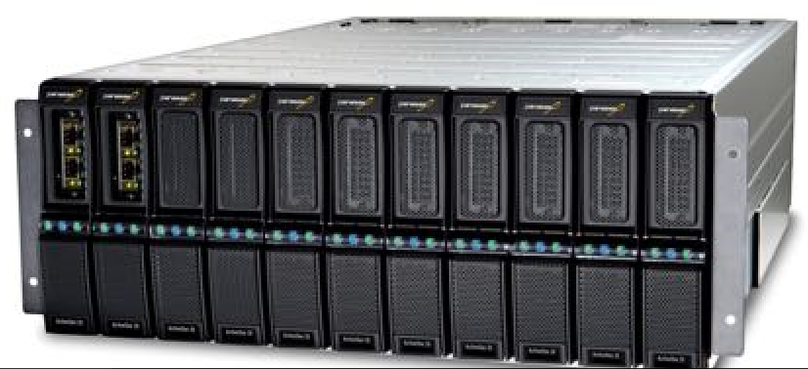
Figure 2 – ActiveStor 20 Shelf
The ActiveStor is described as a shelf enclosure, with a 4U rack size. Currently a single ActiveStor 20 supports 208TB of storage with read/write performance up to 1.8/1.6GB/s respectively. Scaling is simple – just add more ActiveStor’s! Currently peak capacity is 45PB with peak throughput at 360GB/s. Measured in terms of IOPS, a single ActiveStor supports 14,150 IOPS, with a total capacity of 2.6m IOPS. Each enclosure has 11 blade slots, which can include up to three director blades, in addition to storage blades.
ActiveStor director blades orchestrate file system activity outside of the data path, allowing reads/writes to occur in parallel directly between compute clients and Panasas storage blades, hence optimising data transfer and ensuring scalability In addition, director blades virtualise data objects across all available storage blades, enabling the system to be viewed as a single namespace. They also automatically cluster together for high availability, minimising management requirements and maximising resilience. Additionally, an InfiniBand router/gateway can be added, allowing access to InfiniBand clients. Each router provides a 40Gbps QSFP InfiniBand interface, two bonded 10Gbps Ethernet interfaces and a single IPMI management interface.
From a software perspective, in addition to the PanActive manager GUI (see next section), the Panasas solution includes load-balancing, snapshots, data replication and analytics. Historically, vendors would offer these as expensive add-ons, or via a 3rd party product, so this is yet another cost-effective element to the overall package, which also adds to the overall ease of management, as well as lowering initial CapEx.

Deployment And Management
In this world of 7x24 operations, a manufacturer cannot simply close a factory for the weekend in order to update a storage system or change over to a new solution.
Customer Reference: When designing the Dreamliner for safety, material and fuel efficiency Boeing relied on Panasas to support the extreme workload.
Here is where speed of deployment and scalability are key. The Panasas NAS solution has independently been verified as taking less than 10 minutes to set up. This would have been unheard of a few years ago and, 15 years ago we’d have been measuring deployment time in days and weeks! Scaling out is literally an extension of the initial deployment. A single, unified name space makes extending the storage as simple as it’s possible to be. And, to further optimise speed and performance, files are automatically load-balanced as they are added. Further optimisation is provided by an object based per-file RAID system. This reduces risk and increases availability with triple mirroring of small files, while large files are striped, so even multiple drive failures (unlikely) are covered off.
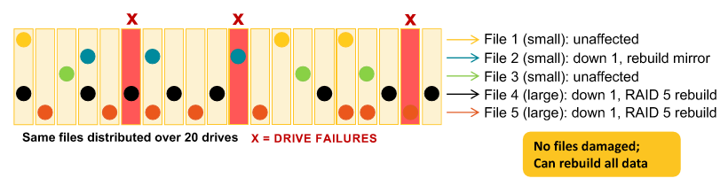
Figure 3 – Per-File RAID System
Customer Reference: CD-adapco is pioneering MDX, using engineering data from simulation results to improve a product through multiple design iterations, using it to maximize the real-life performance of products in the aerospace, automotive, energy, life sciences, and oil and gas industries.
Legacy NAS was unable to keep up with I/O requirements of the highly data-intensive CFD calculations, so CD-adapco needed a storage solution that could improve system performance, minimise administration and maintenance time, and provide high reliability.
“When we turned on the Panasas system, the bottlenecks disappeared and we were able to run a complex MDX simulation without impacting other system users,” said Steven Feldman, senior vice president of information technology at CD-adapco. “We deployed Panasas on all mission-critical systems and find that storage and data loss is now something we just don’t worry about. In addition, administration for Panasas storage is almost non-existent.”
With ActiveStor and its use of parallel data paths, CD-adapco was able to substantially increase data throughput to meet the high-performance requirements of MDX simulations, while maintaining high reliability
Day to day management is via a single management view using the integrated PanActive Manager GUI (a CLI is also available). Automated snapshots and user quotas further reduce administrator time and SNMP is supported for integration with 2rd party systems.
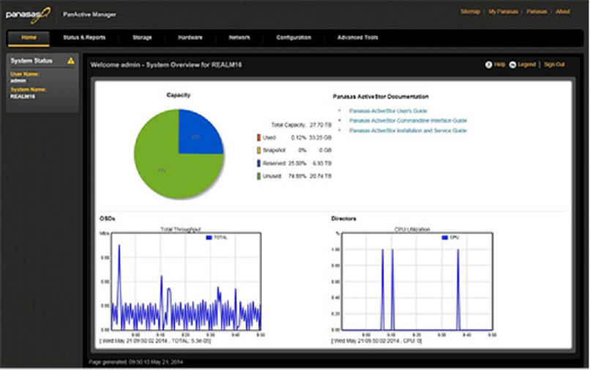
Figure 4 – PanActive Management GUI
Customer Reference: “Anything we can do to cut costs, improve reliability and robustness and save time is critical to us. Speeding up the design and simulation process with platforms like Panasas ActiveStor saves us an incredible amount of time and money.”

In Conclusion
NAS storage requirements for pretty well any company are radically different to what they were a few years ago.
The emergence of large, unstructured data has changed the rules. In manufacturing especially, those rules need to be obeyed, otherwise the potential costs of delayed delivery, research and development restrictions and sheer data unavailability are all but unthinkable. So identifying all opportunities to save time, improve design and analysis capabilities and productivity and maximise system reliability should be the “go to” message to any manufacturer looking for a contemporary NAS scale-out solution.
Unlike traditional NAS or SAN storage, Panasas products can scale both capacity and performance while remaining simple to manage. With its ease and speed of deployment and scaling, performance through parallel workflow processing and built-in resilience, Panasas is doing an excellent job of ticking all the relevant boxes. And while the general message is that, today, performance is every bit as important as cost per terabyte, Panasas claims to offer twice the performance, in terms of bang per buck, compared with its established competitors, so both CapEx and OpEx angles appear to be covered.
Definitely one for the shortlist…

